Dobot Startup Guide
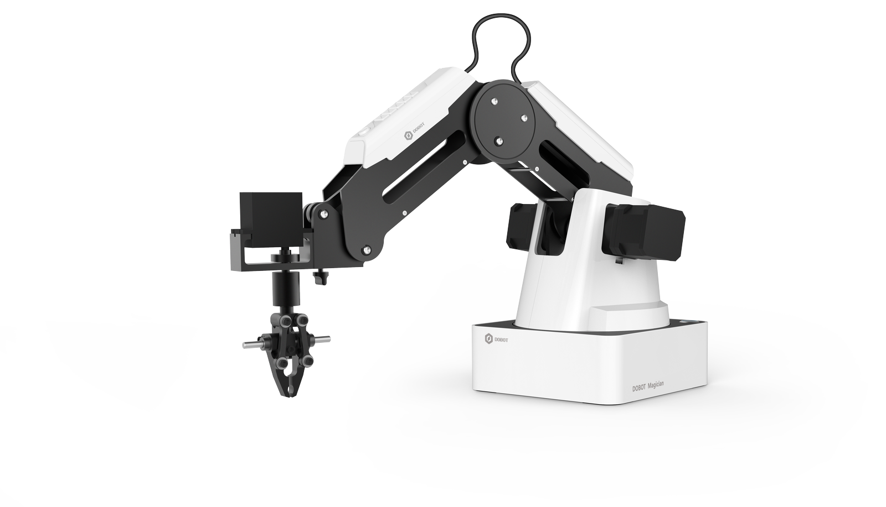
This guide will walk you through the process of setting up your new Dobot.

Unboxing
Powering On and Connecting
Firmware Update
Safety Tips
Installing Attachments
Air Pump
Pneumatic Gripper
Suction Cup
Writing Accessory
Coding with Blockly
Blockly Index
Logic
Loops
Math
Text
Lists
Colour
Variables
Functions
DobotAPI
Basic
Config
Motion
I/O
Additional
Code Examples
Troubleshooting
Suction Cup
Conveyor belt

Unboxing
Here are the components that will come included in your Dobot kit.
- Robot Arm
- Power Adapter
- USB Cable
- Writing Drawing Kit
  - Pen Holder
  - Pen
- Pneumatic Kit
  - Pneumatic Gripper
  - Suction cup and joint
  - Air Pump Controller
- Tool Package
  - Hexagon Screwdriver M1.5 M2 M2.5
  - Quick Fix Screw
  - Calibration Tool
- 3D Printing Kit
  - Extruder
  - Hot End
  - 3D Printing Filament Holder
  - Filament 200g
  - Masking Tape
- Laser Kit
  - Laser Module
  - Laser Protective Glasses
- WIFI Module
- Bluetooth Module
- Joystick Control Kit
  - USB connector Host
  - Joystick
In your Dobot box you will find a Shipping List with a diagram of where you can find these parts in your box. Please refer to the Installing Attachments section to see pictures of these parts and learn how to use them.

Powering On and Connecting
#1 Download DobotStudio for your PC here: http://www.dobot.cc/download-center/dobot-magician.html

#2 Plug your Dobot into the wall using the power supply provided.

#3 Find the white cover on the forearm of the robot
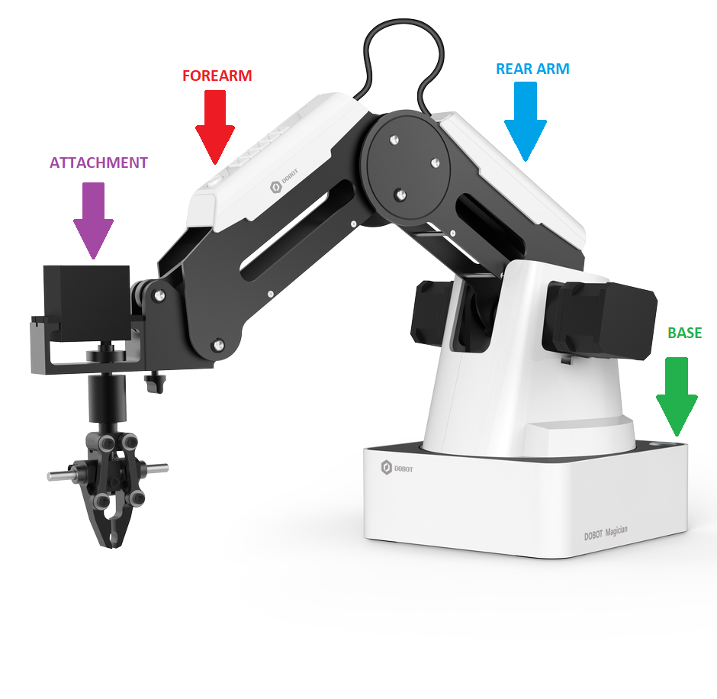
There you will find a white button with a lock symbol.
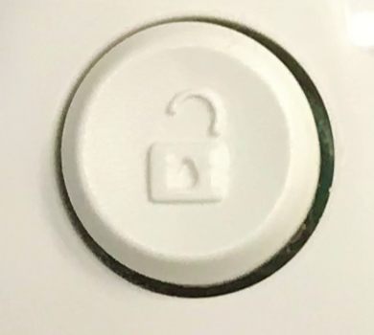
Press the button in order to unlock the arm. While the button is pressed, you can maneuver the arm. Do not attempt to move the arm without first pressing down on the unlock button, or it may damage your robot.

#4 Make the angles between the forearm and rear arm about 45°

#5 You may now power the robot on using the power button at the top right of the base. Press the button, and you should notice three things:
- The power button turns blue
- After about 10 seconds, there will be a short sound.
- The light at the bottom left of the base controller goes from yellow to green.
Note that if the light has changed into red, it means Dobot is in a bad position. Press the unlock button and position the Dobot so the angles between the forearm and rear arm are about 45°.

#6 To connect your Dobot to your PC computer, plug the provided USB cable into your computer, and plug the other end into the port on the back of the base labeled “USB”.

#7 Open DobotStudio, and find this button in the top left corner of the screen:
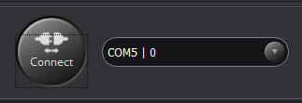
Ensure that you have selected COM5 from the dropdown menu to the right, then click connect. You are now connected to your Dobot!

Try pressing some of the buttons on the operation panel to see your Dobot move!
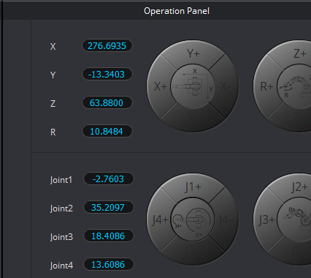

Firmware Update
Do a firmware update as soon as you have your Dobot setup, and whenever you see a popup recommending a new update. The process is simple and takes less than 5 minutes.

#1 Click the settings button at the top right corner of your screen
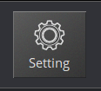
#2 Choose Firmware from the menu.
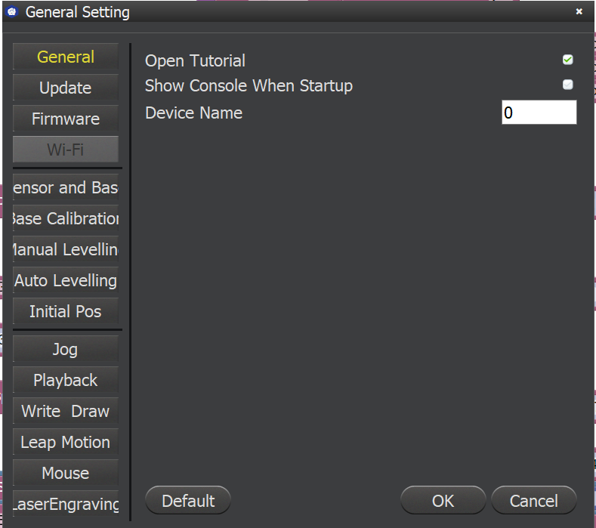
#3 Robot must be disconnected to continue, click OK.
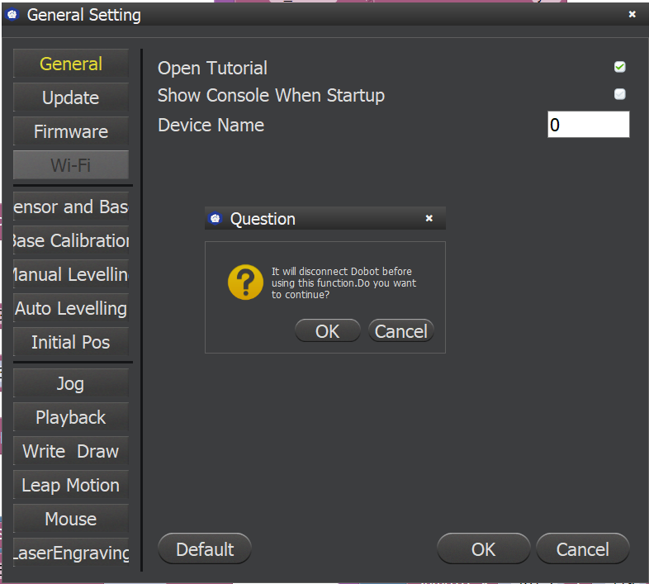
#4 Make sure Dobot Firmware is selected, then press Confirm.
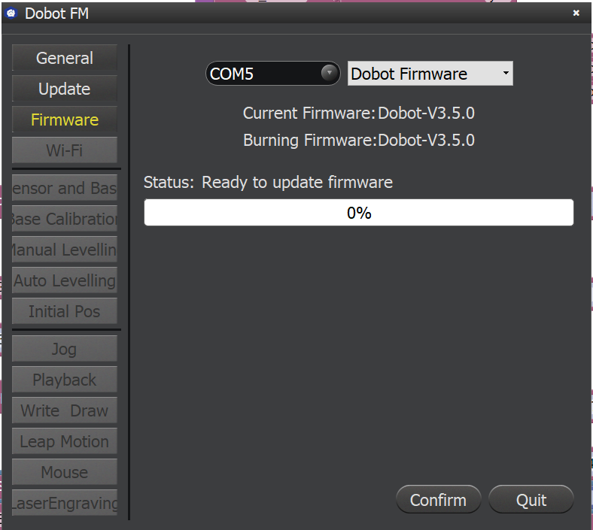
#5 DO NOT power off Dobot during this process.
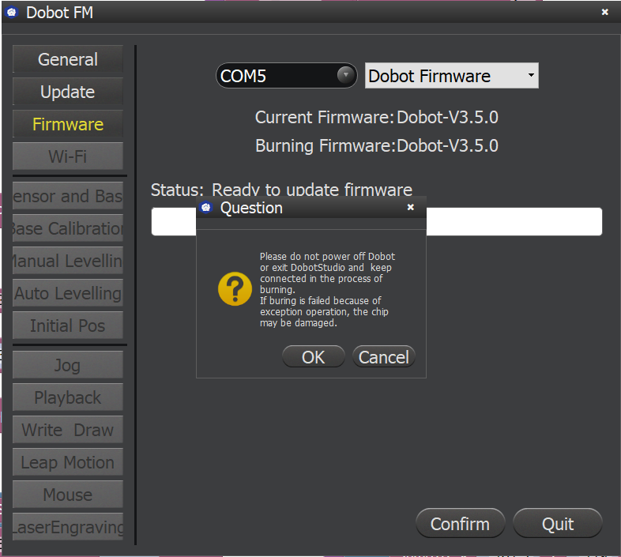
#6 After the update is complete, press Quit.

Safety Tips
- This kit contains many small parts. moving parts, and parts that create heat. It should be kept away from small children.
- Older children should be supervised at all times while using Dobot.
- Do not place your hands in the operating zone of the robot during use, or they may be pinched.
- When using Dobot, be mindful of your surroundings. Do not place Dobot in an area where it may knock over/become entangled with other objects.
- Be careful to not allow dobot to become entangled in its own cords. Fee free to hold them away from the robot if you feel they may get in the way during a task.

Installing Attachments

Air Pump
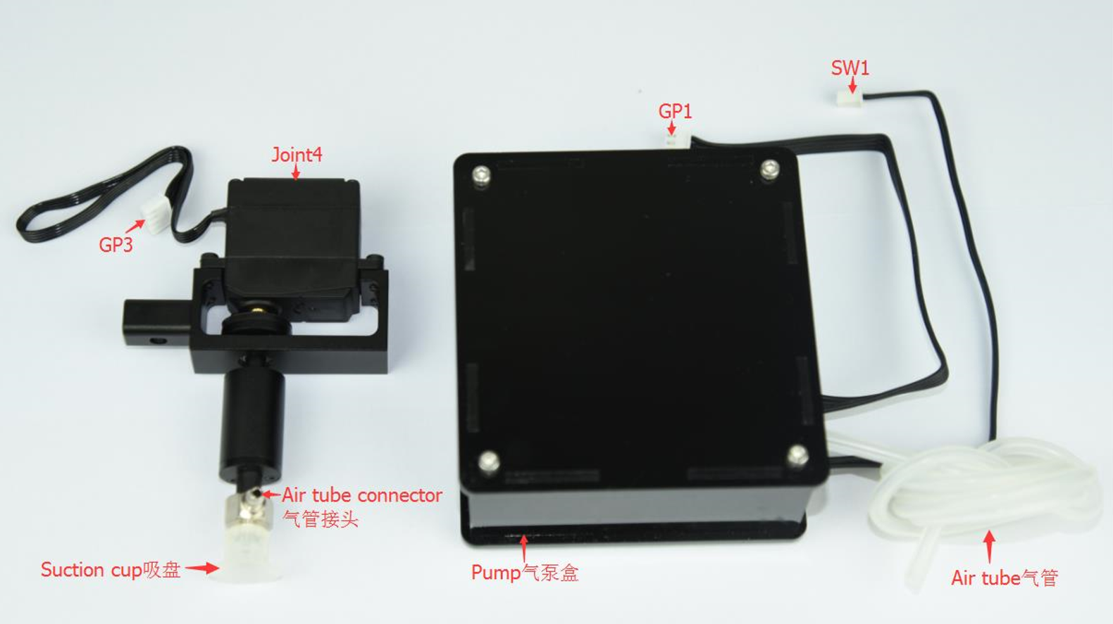

The air pump is the mechanism that provides gripping and suction power to the gripper and suction cup attachments. These attachments will not function without the air pump.
- Connect power line labeled SW1 on the pump box with the interface on the Dobot labeled GP1.
- Tighten air pump kit onto the end of the Dobot with the butterfly nut.
- Connect windpipe on the controller box with pipe connector on the pump box.
- Connect GP3 of Joint4 servo line with forearm connector GP3.
- The installation should look like this:
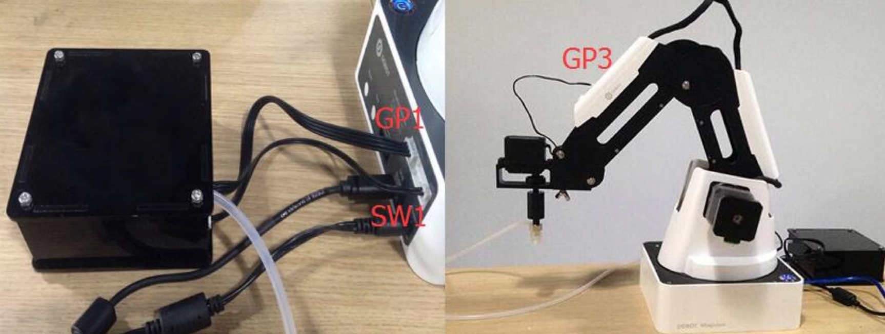

Video instructions for how to install and use the air pump are included in the suction cup attachment section.

Pneumatic Gripper
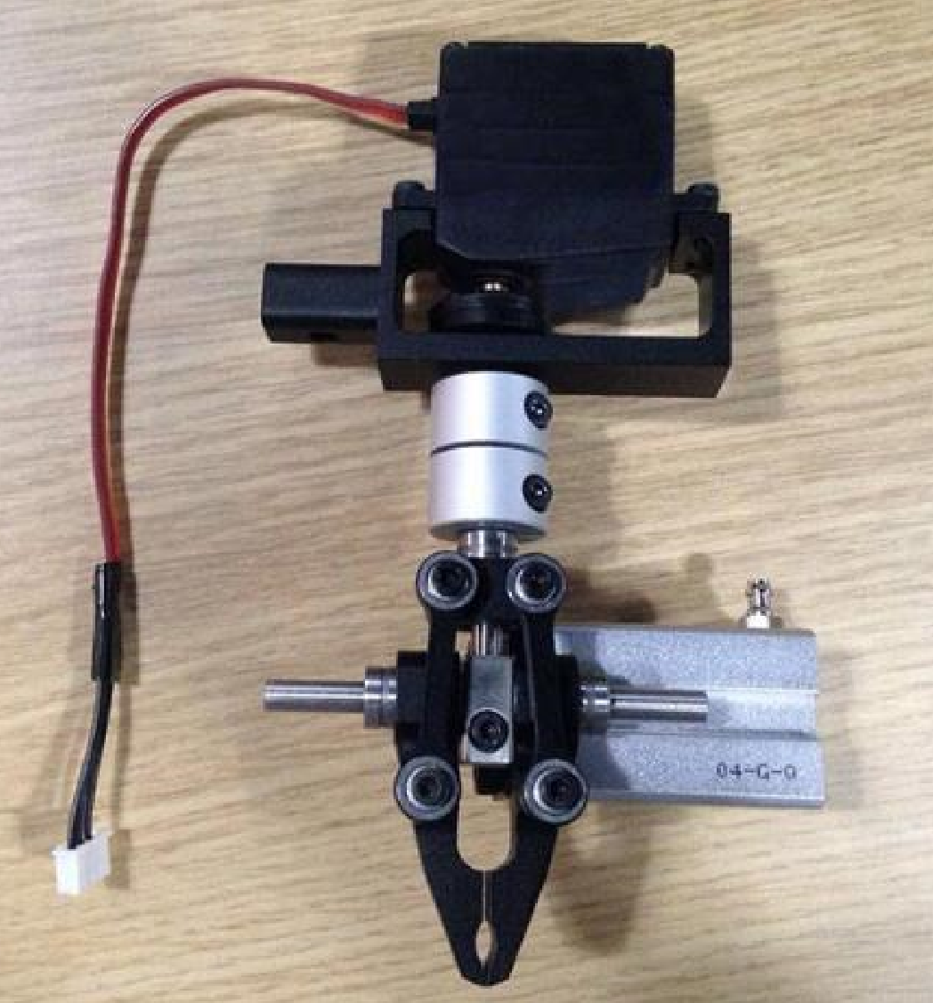
The gripper and suction cup attachments share the same air pump kit. So when switching between those two attachments it is faster to just remove the gripper or suction cup.

- Unscrew the suction cup with the hex wrench. Be careful, the screws are very tiny. It might help to hold them in a water bottle cap if you are worried about misplacing them.
- Install the gripper kit on Joint 4 with the coupler, as shown below:
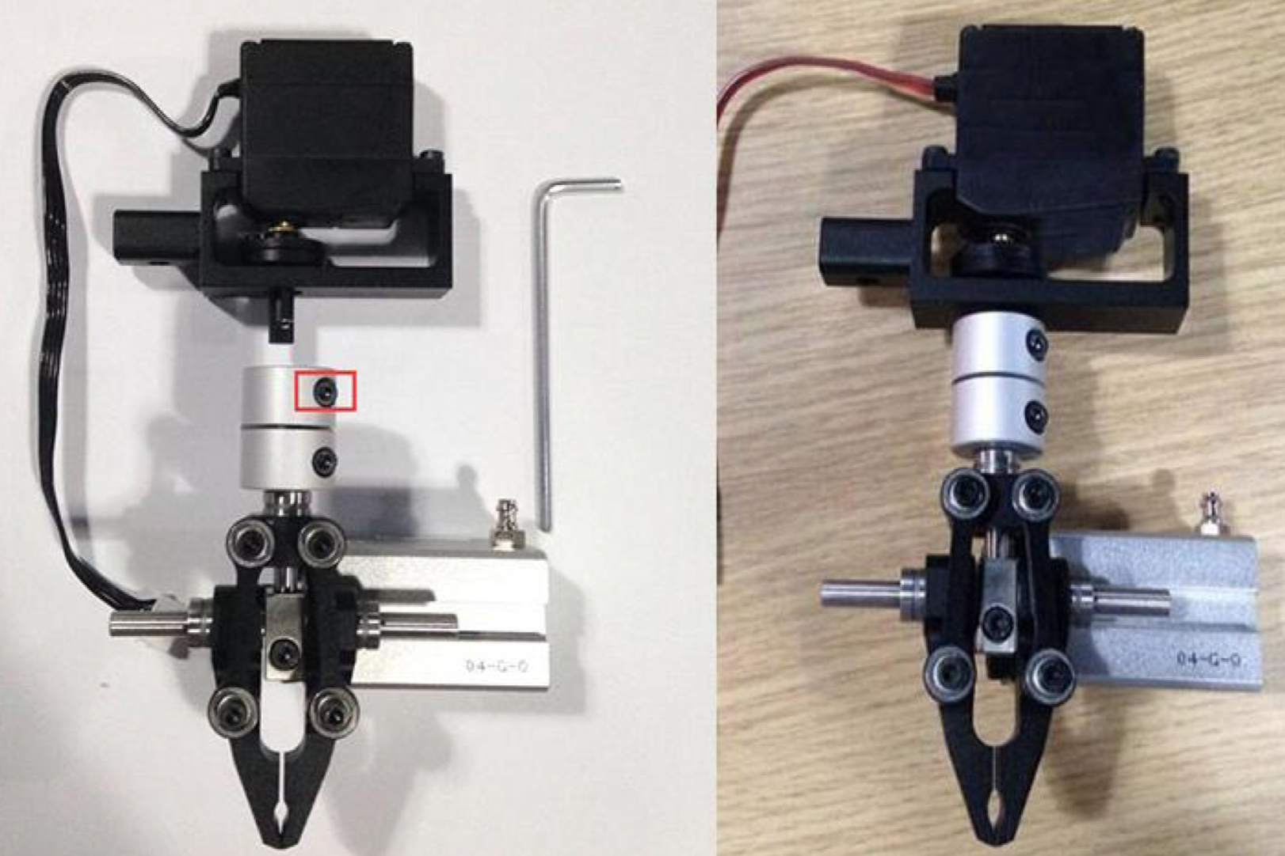

Suction Cup
Please watch this video for instructions on how to install and use the suction cup attachment:
https://www.youtube.com/watch?v=2uamdwwp7eM

Writing Accessory
Please watch this video for instructions on how to install and use the writing attachment:
https://www.youtube.com/watch?v=tHnHYBzcwa0

3D Printer
There are several attachments needed to use the 3D printer:

- Before you print, make sure to set up a safe printing environment. Protect your work surface by placing the clear glass plate on the table and securing it with the masking tape provided.
  - Keep your own safety in mind too! The 3D printer reaches high temperatures in order to melt the filament. Do NOT touch the hot end attachment or the printed object for 20 minutes after the printing has completed.
- Take out the extruder and hot end. Install the hot end the same way you installed the other attachments.
  - Connect the power line labeled SW3 to #5 on the forearm
  - Connect the power line labeled SW4 to #4 on the forearm
  - Connect the power line labeled ANALOG to #6 on the forearm

Please watch this video for further instructions on how to install and use the 3D printing attachment:
https://www.youtube.com/watch?v=6SsQB4_a2ig

Coding with Blockly
To get to the Blockly coding environment, open DobotStudio and click the Blockly button pictured below.
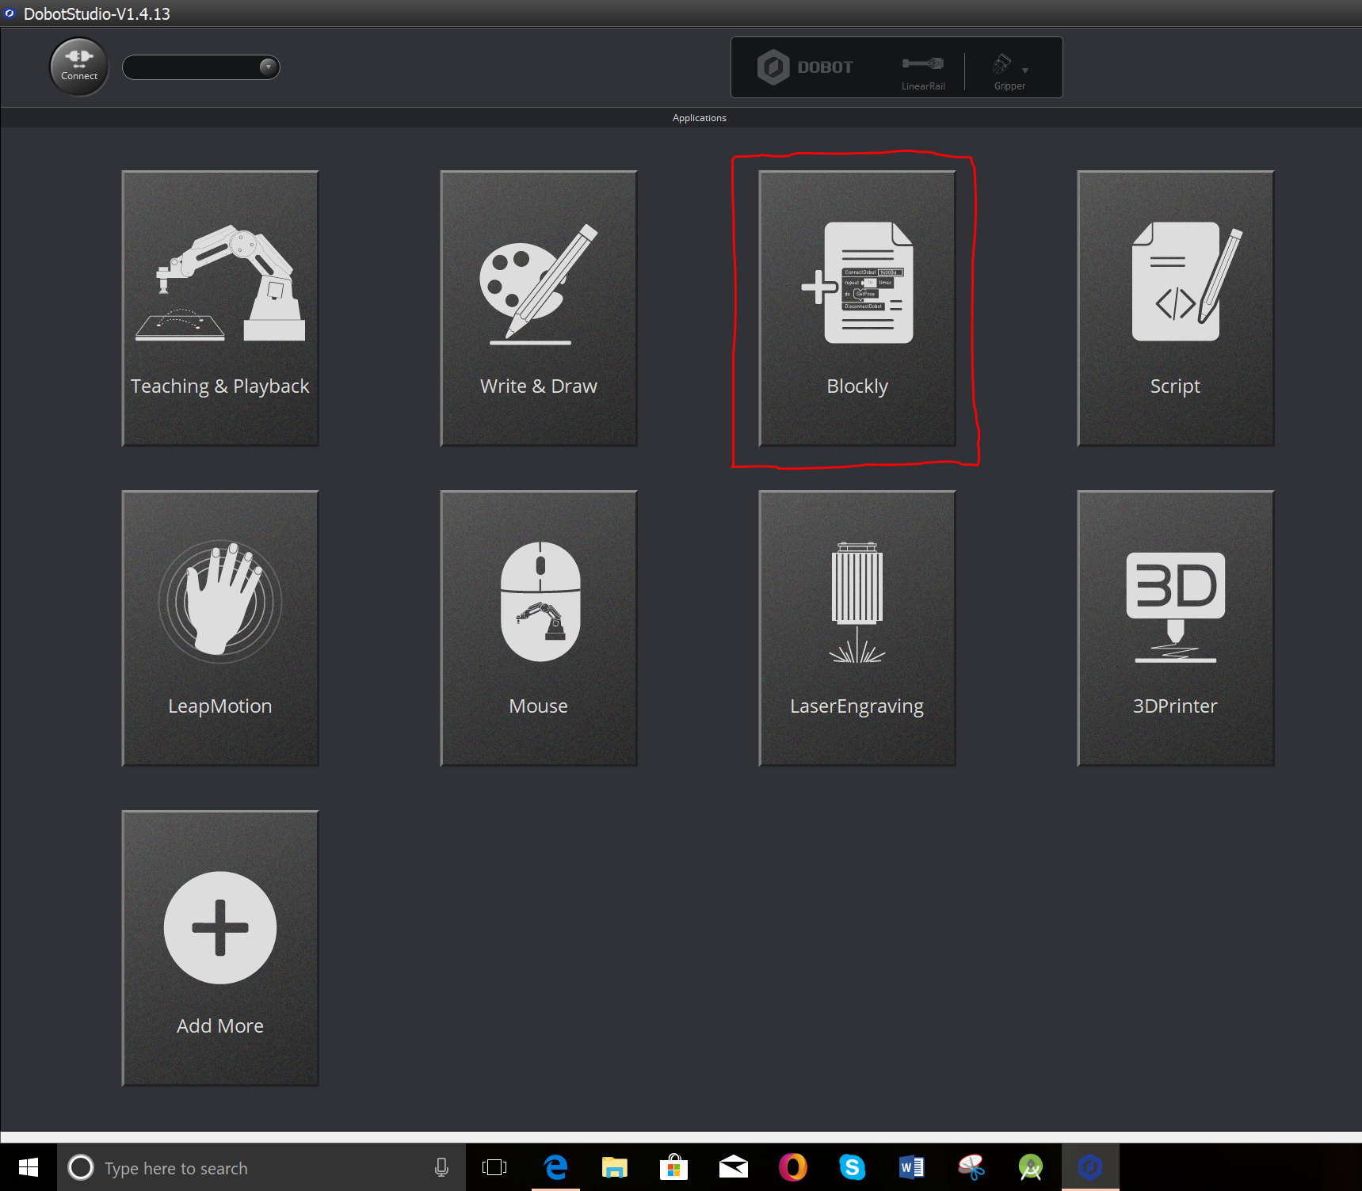
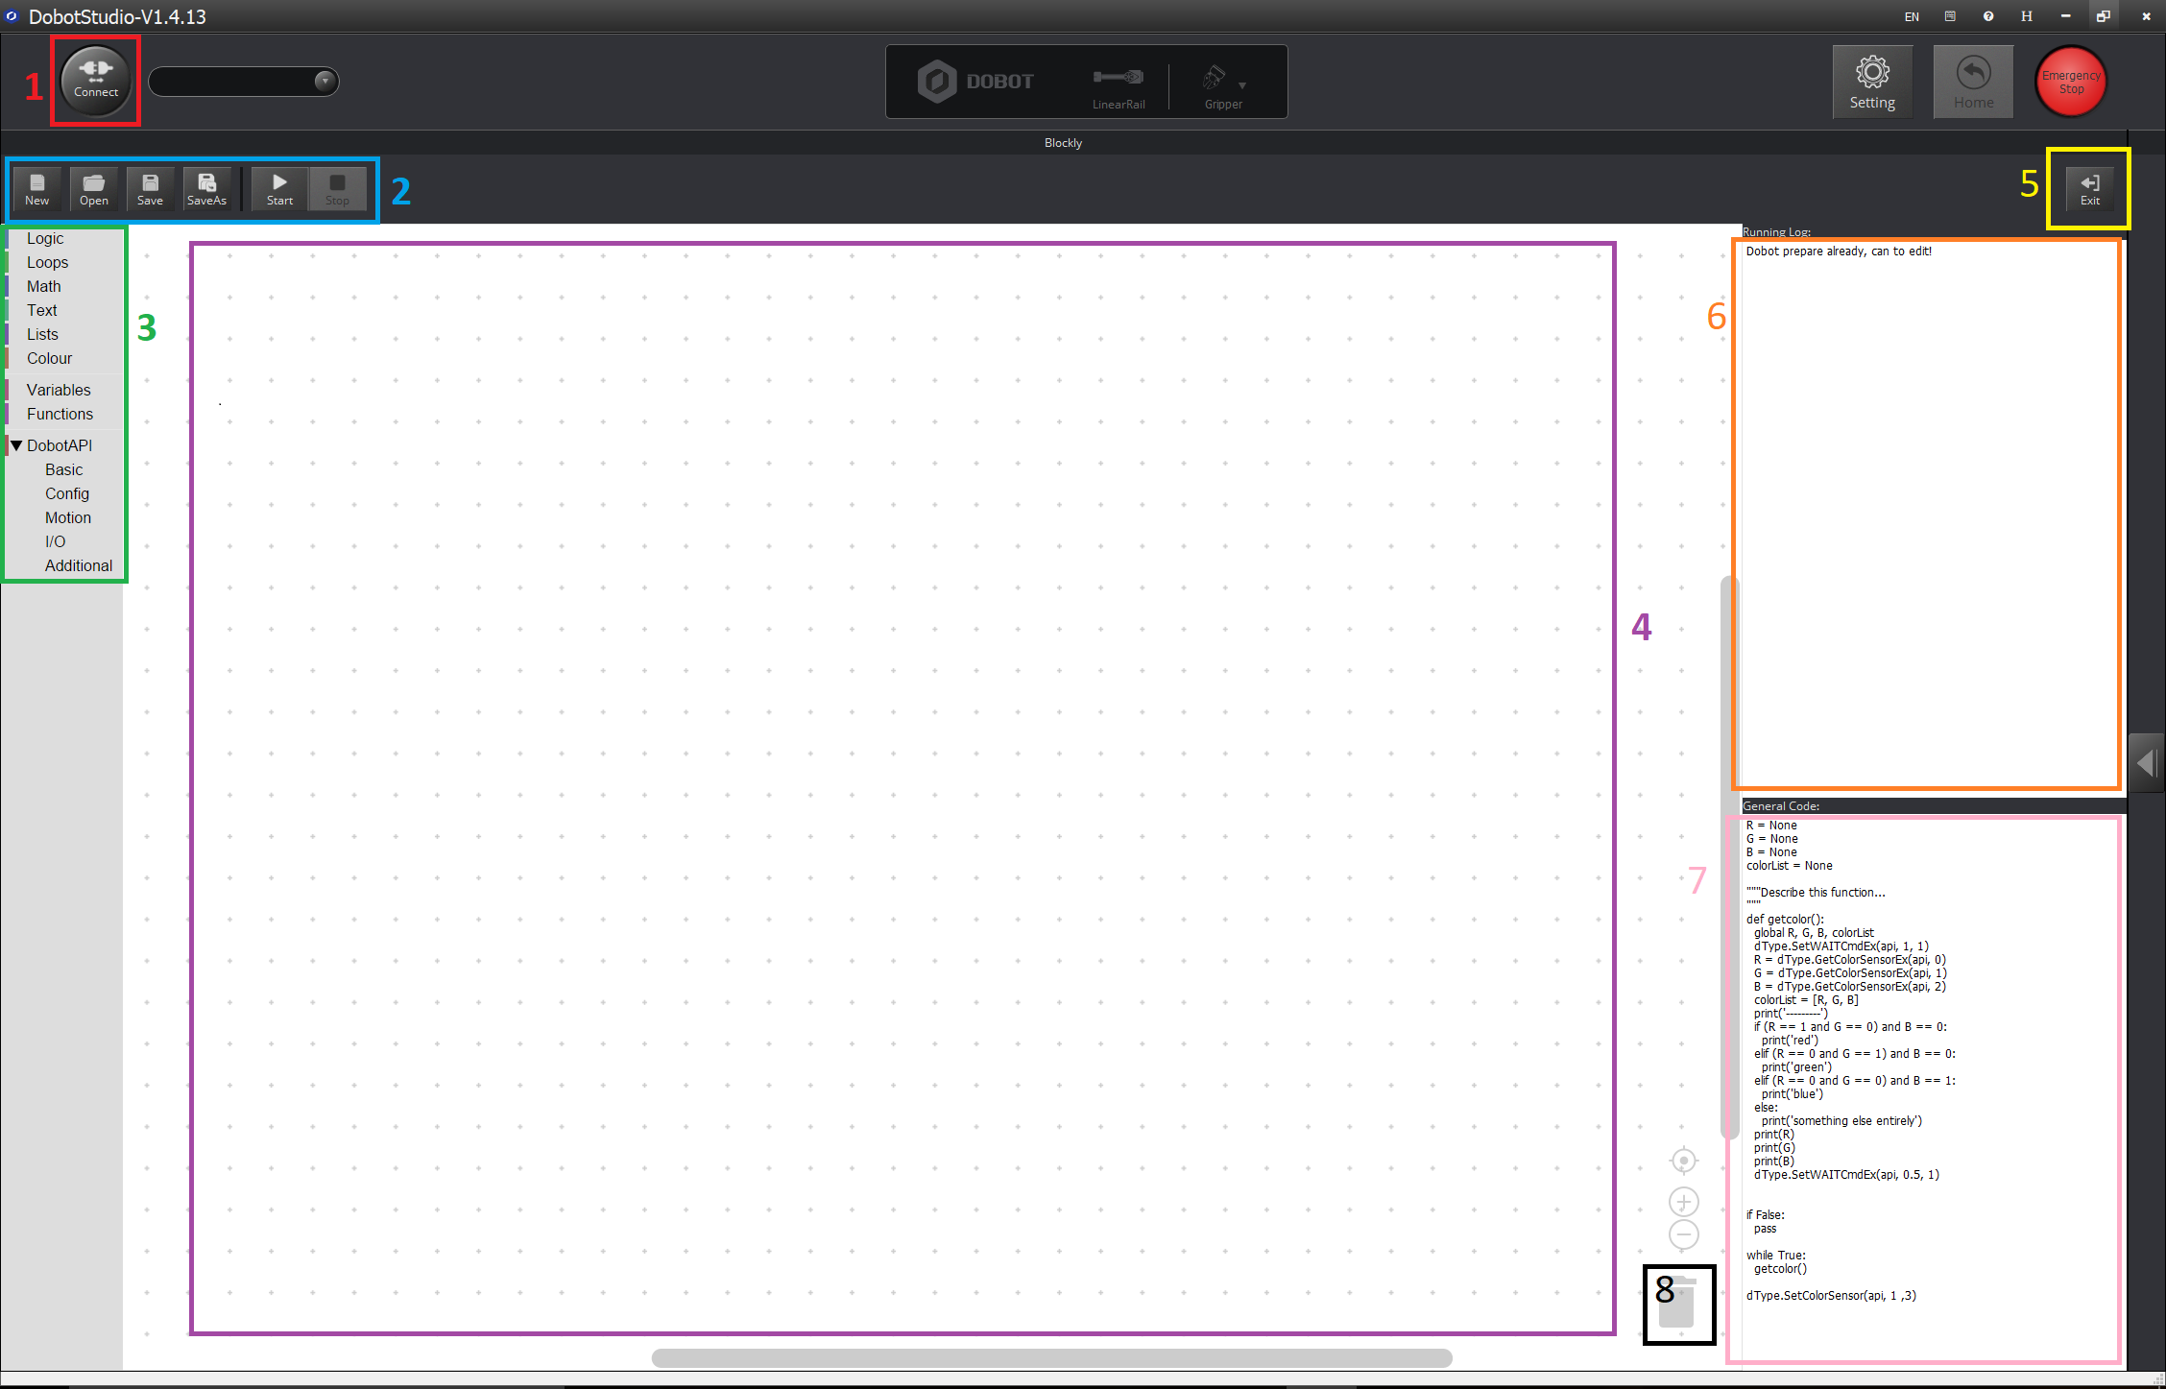
You will see the Blockly coding environment. The different parts of the environment and their functions are outlined below.
#1 Connect
Once you have your USB cable connected to your computer and the Dobot, click the connect button to start a connection control your Dobot through your PC laptop. Click again to disconnect.

#2 Menu
New - Create a new file (make sure to save anything you want to keep before you click this button.
Open - Open one of your saved files.
Save - Save a file you have been working on.
SaveAs - Name and save a file.
Start - Start your program (only works when you are connected)
Stop - Stop a program that is currently running.

#3 Blockly Blocks
This is the menu where you will find all the Blockly blocks. These blocks can be combined to create thousands of programs. See the Blockly Index for descriptions of each block.

#4 Workspace
This is where you will drag the Blockly blocks to create your programs.

#5 Exit
Click here to exit the Blockly programming environment and return to the main menu.

#6 Running Log
This log will show the errors and warnings from your programs, and anything you decide to print during your programs.

#7 General Code
This area translates your Blockly code to easily readable Python.

#8 Trash
If you don’t need a certain section of code anymore, drag it to the trash can. But be careful, once you throw it away you cannot get it back!

Blockly Index
Check this index for general definitions of the Blockly blocks. For examples and in-depth descriptions, refer to the Code Examples section.

Logic
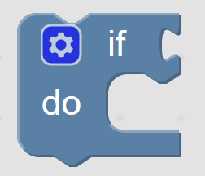 | If statement  The if statement is a simple conditional that works like this:  IF <the condition is met>  DO <the action you specify>
Comparator
Set a variable equal to a value. The value can be a number, true or false, a character, or even a String (a series of character like a word or a sentence).
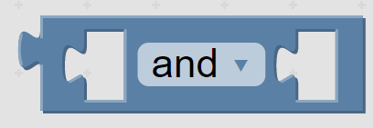 | Logic Gate / And / Or  This block can be nested inside other blocks in situations where you need two values to be checked.
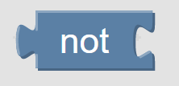 | Not  This block negates any logical operation placed after it.
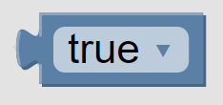 | True/False  This block simply labels something True or False. It can be used to check if something is true.
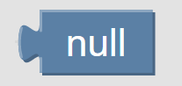 | Null  Null is a way to represent nothing. It is similar to 0, but rather than saving the value 0 in memory it saves nothing at all.
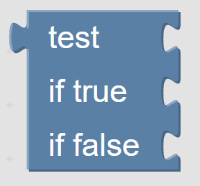 | Test  This is a more specialized version of the if statement you’ve seen before. It allows you to code a response for both true and false outcomes.

Loops
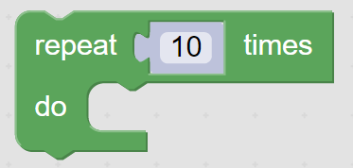 | Repeat X Times  FOR <the # of times you specify>  DO <the action you specify>  No condition needs to be met to make this happen
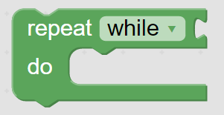 | While Loop  Repeat WHILE <condition is met>  DO <the action you specify>
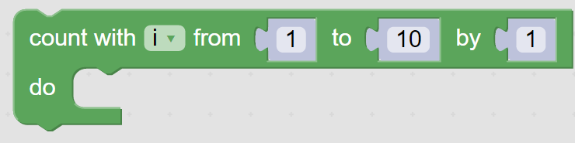 | Iteration Loop  Use the variable “i” to iterate your program every time it loops.
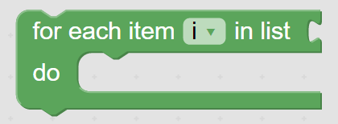 | For Loop  For each item in your list, set the variable “i” to the item, then do some statements.
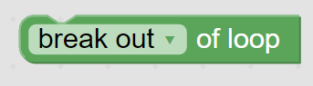 | Break  Break out of a loop without needing to meet any condition.  Go to the next iteration without having to meet any conditions.

Math
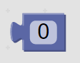 | Number  This block can be any number you choose.
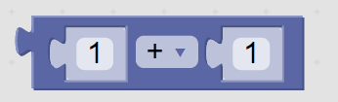 | Math Block  Add, subtract, multiply, divide, or power any numbers you choose.
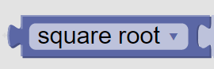 | Calculate  Calculate the square root, absolute value, log and more.
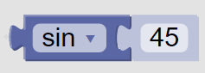 | Angle Block  Calculate sin, cos, tan, and more.
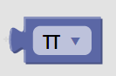 | Pi  This block can represent pi, sqrt(2), e, and more mathematical concepts.
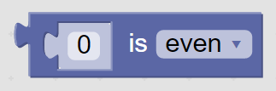 | Even/Odd  Check whether a number is even or odd.
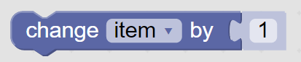 | Change Item/Step  Change a variable by a numerical value of your choice.
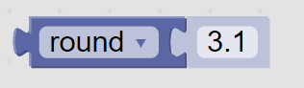 | Round Number  Round a number to the nearest whole number, up, or down.
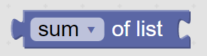 | List Math  Manipulate the values of a list you created.
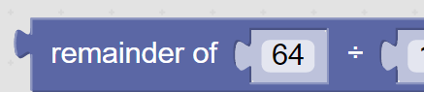 | Remainder/Modulus  Find the remainder when one number is divided by another.
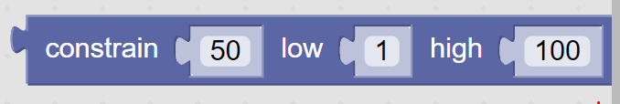 | Constrain  Constrain a number to be between the specified limits.
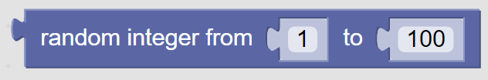 | Random Number  Get a random number between the specified limits.
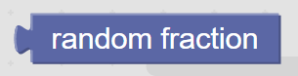 | Random Fraction  Get a random fraction.

Text
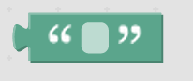 | String  A letter, word or line of text.
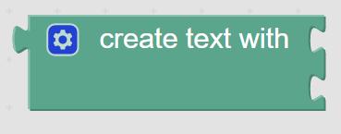 | Create Text  Create text by joining several items.
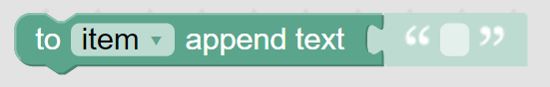 | Append  Append text to the end of another variable.
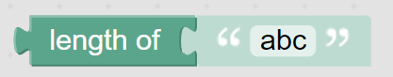 | Get Length  Return the number of letters in the text.
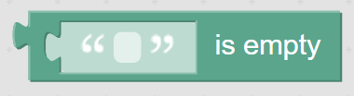 | Is Empty  Determine if the text block is empty.
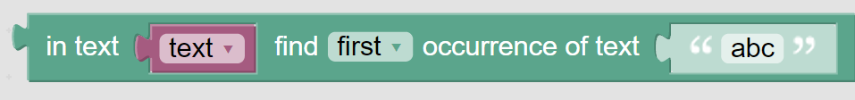 | Find Occurance  Find the first/last occurence of a letter, word, or set of words in a text.
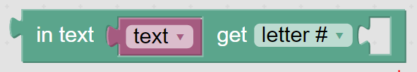 | Find Letter  Get letter #<your choice> from a text.
Find Substring
Get a section of your choice from the text.
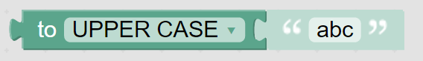 | To Uppercase  Returns text in upper case.
Trim
Trims the spaces on either side of a word or phrase.
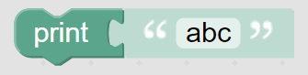 | Print  Print a letter, word, or phrase.
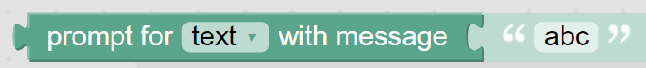 | Prompt  Return some text and prompt for user input from the keyboard.

Lists

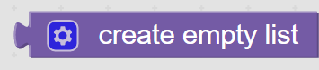 | Create Empty List  Create an empty list that you can assign items to later.
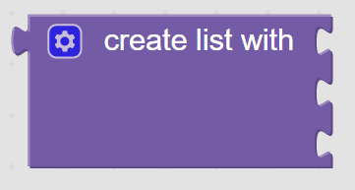 | Create List  Create a list with items that you specify individually.
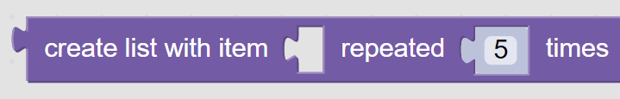 | Create Repeat List  Create a list with one item repeated several times (more quickly than adding them individually).
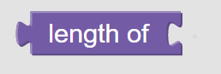 | List Length  Return the length of the list.
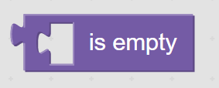 | Is Empty  Return if the list is empty.
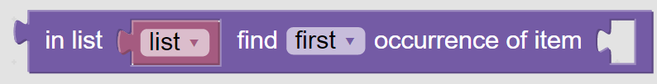 | Find Item by Occurence  Find an occurence of a specific item in a list.
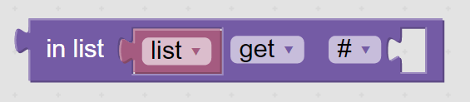 | Find Item by Number  Get a specific item in a list (based on its order).
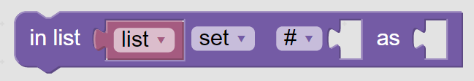 | Set Item by Number  Set the value of a specific space in the list.
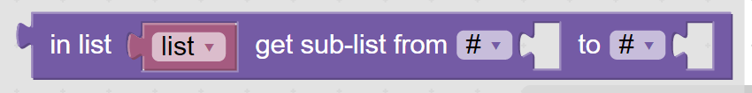 | Get Sublist  Make a sublist from a certain section of an existing list.
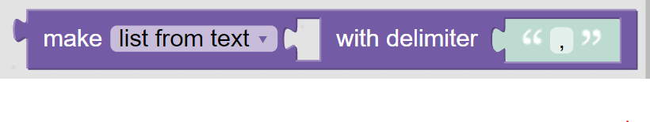 | List From Text  Make a list from text, or make text from a list. The delimiter is what you choose to seperate the values.
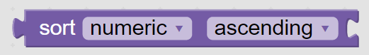 | Sort List  Sort your list numerically or alphabetically.

Colour

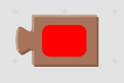 | Color  Choose a color from a large grid of colors.
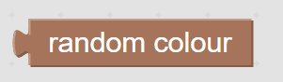 | Random Color  Returns a random color.
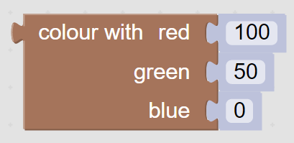 | Create Color  Create a color using RGB values.
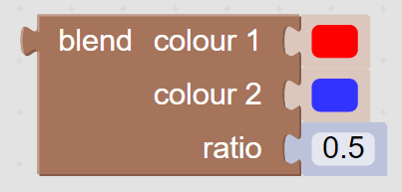 | Blend Color  Create a color by blending two colors you choose.

Variables
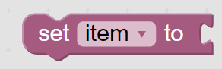 | Set Variable  Create a new variable and give it a value.
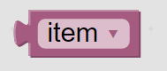 | Get Variable  Refer to a variable that you made previously.

Functions

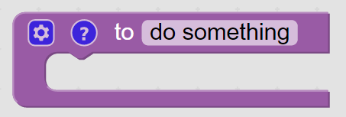 | Function  Create a function.
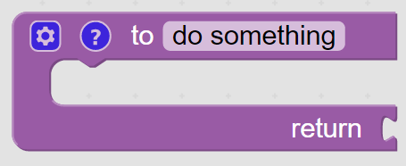 | Function with Return  Create a function with output.
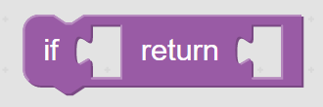 | Conditional  If the value is true, then return a second value.

DobotAPI

Basic

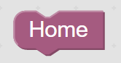 | Home  Put the Dobot in the Home position.
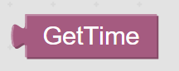 | Get Time  Get the current time.
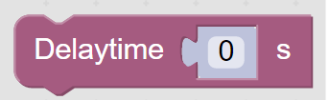 | Delay Time  Stop the program from moving onto the next block for <specified> number of seconds.

Config
Our courses the default configuration, you will not need to configure your robot differently. Any block you will not need to use is marked NA.
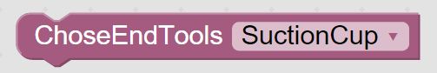 | Choose Tool  Tell the program what attachment you are using for the Dobot.
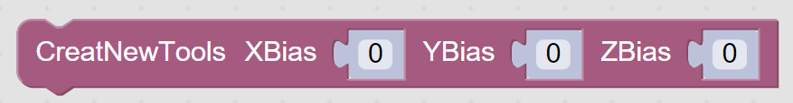 | NA
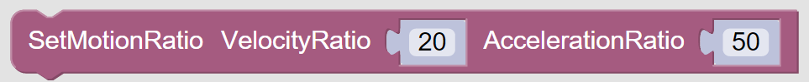 | NA
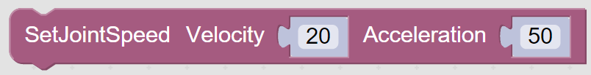 | NA
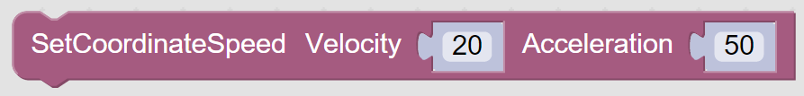 | NA
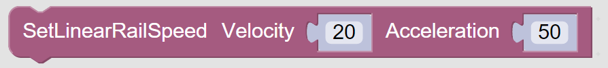 | NA
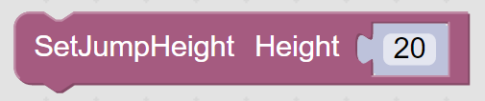 | NA
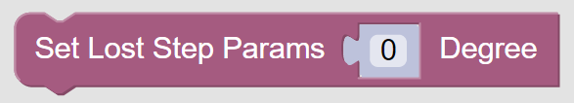 | NA

Motion

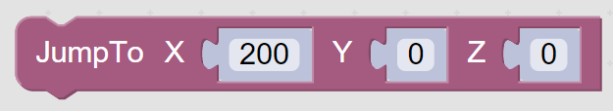 | Jump To  Move the arm by specifying new coordinates.
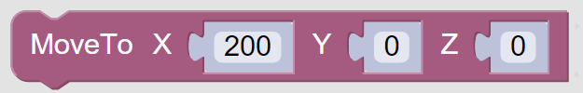 | Move To  Move the arm by specifying new coordinates.
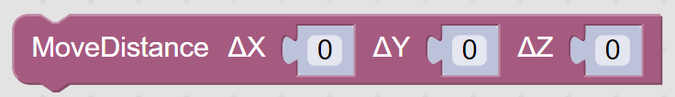 | Move Distance  Move the arm by specifying the change in location from start to finish rather than the new coordinates.
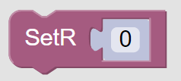 | Set R  R is the rotation of Dobot’s last joint (the one with the attachment) the default rotation is 0 (pointing straight down).
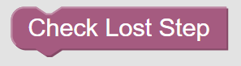 | NA
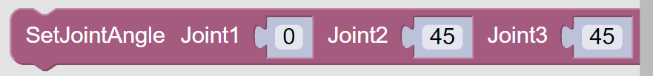 | Set Joint Angle  Rotates the joints of the robot (this is different than moving the joints).
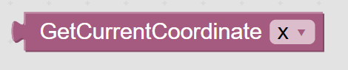 | Get Current Coordinate  Get the current location in space in the X, Y, or Z direction.
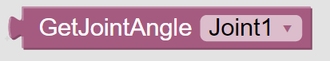 | Get Joint Angle  Get the angle value of any of the robots joints.
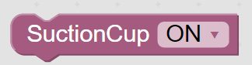 | Suction Cup On/Off  Turn the suction cup on and off during the run of the program.
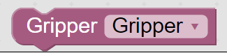 | Gripper On/Off  Open and release the gripper during the run of the program.

I/O

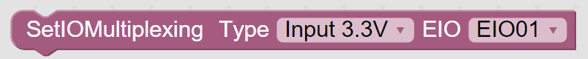 | NA
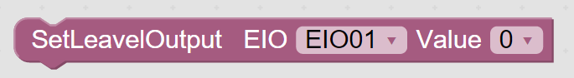 | NA
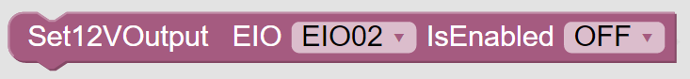 | NA
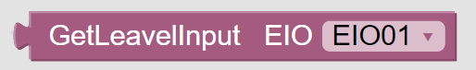 | NA
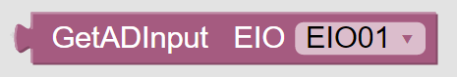 | NA
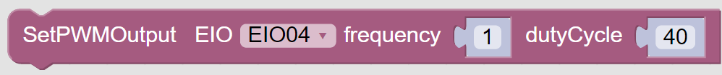 | NA
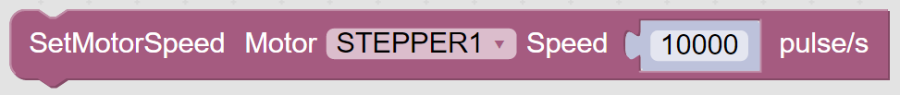 | NA
 | NA

Additional
For safety reasons, our lessons do not cover the use of the 3D printing attachment or the laser engraver attachment, but these blocks are defined in case you’d like to use them for your own purposes.
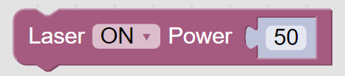 | Laser On/Off  Turns the laser engraver on/off, and sets the power value.
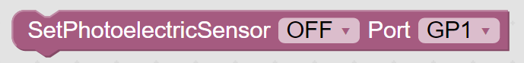 | Set Photoelectric Sensor  Turn the photo sensor on/off, tell the program what port the sensor is plugged into.
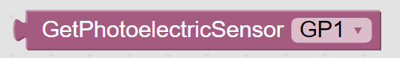 | Get Photoelectric Sensor
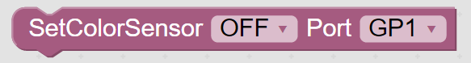 | Set Color Sensor  Turn color sensor on/off, tell the program what port the color sensor is plugged into.
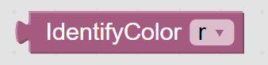 | Identify Color  Identify a color that has been presented to the sensor. The sensor can recognise red and blue. (green can be recognised but lighting heavily affect the accuracy for this color).
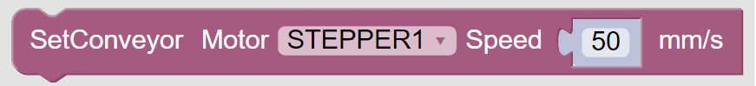 | Set Conveyor  Set the motor the conveyer will use and the speed it will move.
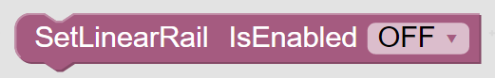
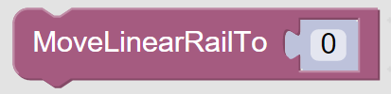

Code Examples
These examples may help you to understand the functionality of each block. Each example has a title in bold, containing all the concepts covered in the example. Try ctrl+F to find an example of the concept you need help with.

If / And / Or / Print / is Even
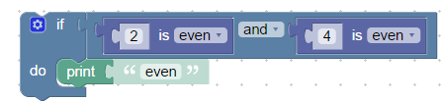
If the number 2 and the number 4 are both determined to be even, then the word “even” will be printed in the log. What would happen if you changed one or both of the numbers to odd numbers? The code would no longer print the word “even” in the log.
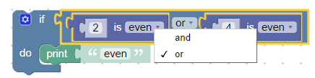
You can change the Blocks setting from And to Or, and completely change the function of the program. Now only one of the numbers must be even in order for the program to print “even” to the log.

Test / If true / If false / Random Number / Print
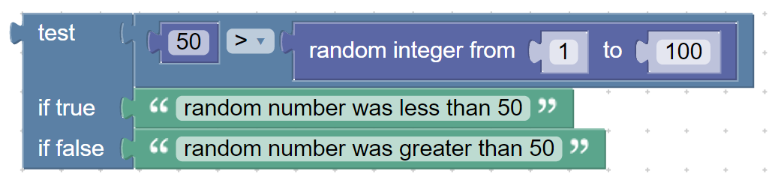
This program will run differently every time. If the random number is less than 50, it will return true and print “random number was less than 50”. If the random number is greater than 50, it will return true and print “random number was greater than 50”.

Gear Button

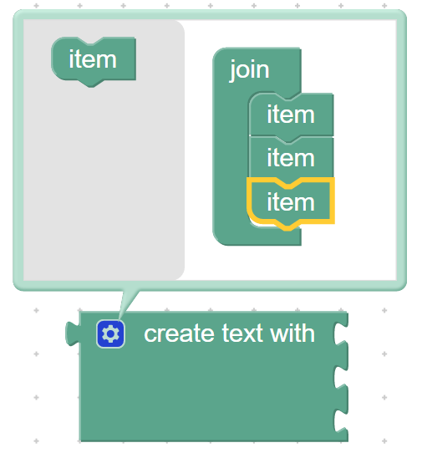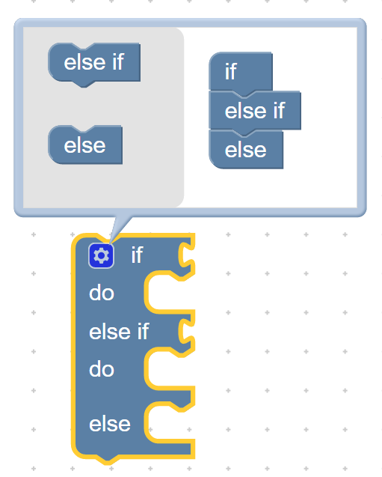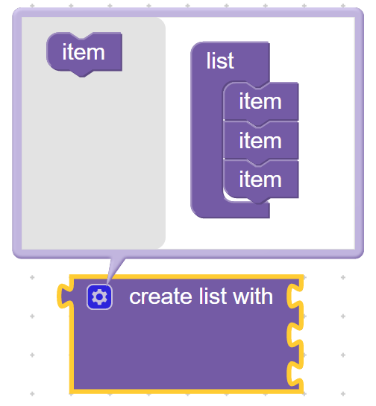
You may have noticed some of the blocks have a small blue gear button. Click the gear to expand or reduce the number of ports on the block according to your needs.

Set Item / Count with “i” / Change item by
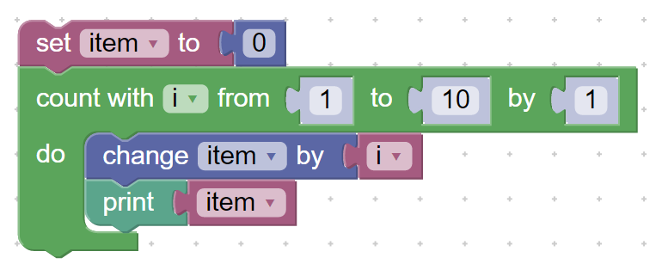
Set the variable “item” to 0.
Loop 10 times. Each time, increase the value of “i” by 1. Add the value of “i” to the value of “item” each time. Here’s how the program goes:
0+1 = 1
1+2 = 3
3+3 = 6
6+4 = 10
10+5 = 15
15+6 = 21
21+7 = 28
28+8 = 36
36+9 = 45
45+10 = 55

Create List / For each Item “i” in List / Append Text
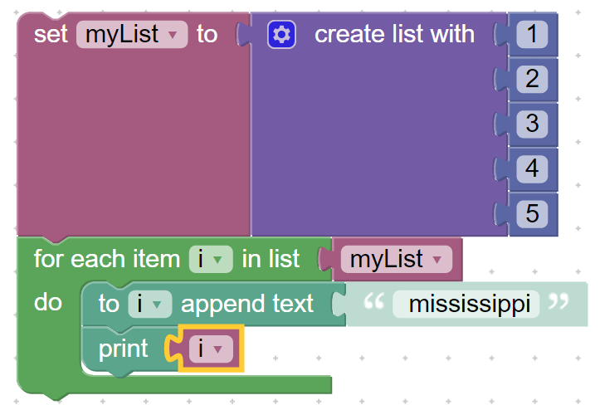
This program uses the Set block to name the list. Make your own new variable like this:
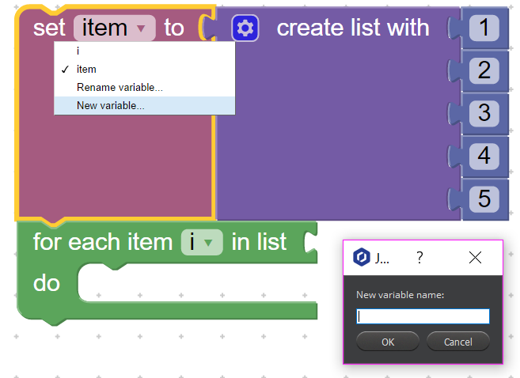
It goes through each item in the list and appends “ mississippi” to the end, then prints the item.

Choose End Tools / Move To / Repeat / Delay Time / Suction Cup

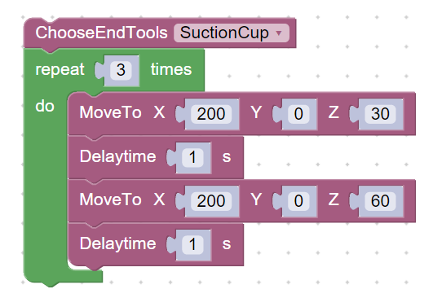
This program specifies the tool attachment ( though it is not used in the program). It then loops a simple up and down movement for the Dobot.

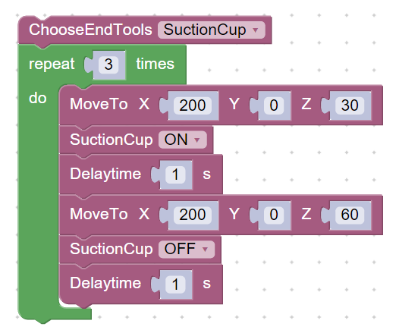
With one small change to the program we added greatly to the functionality. Now when the arm moves up, the suction cup turns on to pick up an object. After the upward movement is complete the suction cup turns off to drop the object.

This final example is a huge leap in complexity, so don’t worry if it is not understandable right away. The program completes the following actions:
- picks up an object
- puts it on the conveyor belt
- moves the object from one end of the conveyor belt to the other
- Stops the conveyor belt when the object is sensed by the photoelectric sensor
- picks the object back up
- Moves it to the color sensor
- Places the object on one side or the other based on whether or not it is red
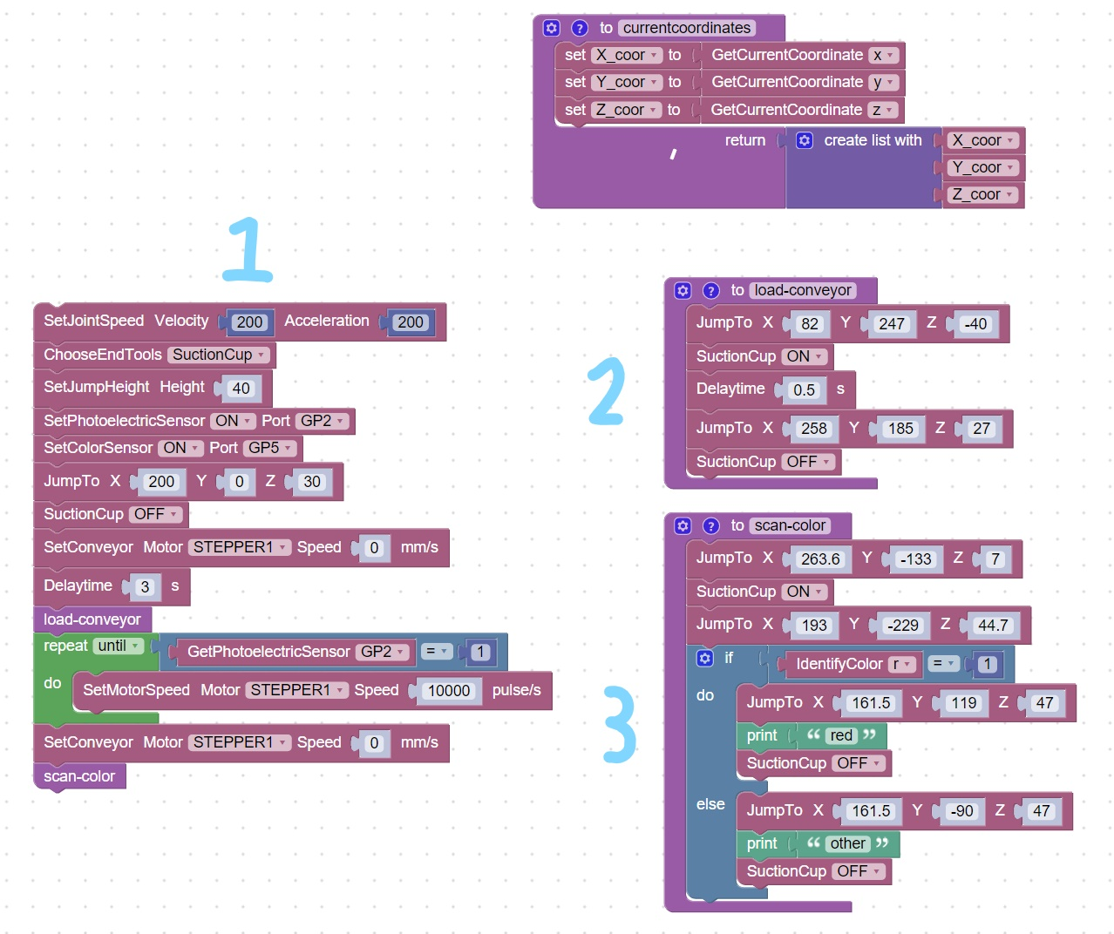
Section 1: This is the control center of the whole program. It sets up Dobot’s behavior such as it’s Joint Speed, End Tool, Conveyor Motor, and Jump Height. It also turns the needed sensors on and identifies where they are plugged in. Then it calls the function load-conveyor. When that is complete, it uses a repeat until loop to

Section 2:
Section 3:

Troubleshooting
Here are some common issues we and our customers have encountered, and how we solved them.

Suction Cup
- The suction cup is properly attached, and I can hear the air pump working, but the suction isn’t working and my Dobot won’t pick anything up.
  - This is most likely a connection issue. Double check that your suction cup attachment and your air pump are plugged into the correct ports. The correct port for the suction cup is GP3, which is the input labeled #1 on Dobot’s forearm. The correct port for the air pump is
  - This could also be an issue of proximity. You must touch suction cup to the object you intend to pick up in order for it to form a seal and move the object. Try changing your code by moving the arm slightly further in the Z direction.

Conveyor belt
- The conveyor belt won’t move, even though it’s in my code.
  - Make sure that the port you plugged the conveyor belts’ motor into is the same as the port specified in your code. The default is STEPPER1 and we recommend you plug your motor into STEPPER1 on your Dobot.
  - This block can also be used

