Statement | Scratch Blocks
Direction:
- Place statements in order.
- Match Scratch blocks.

Stop | 
Turn the headlights on | 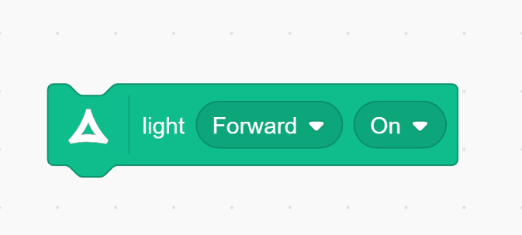
Sense something in front of it | 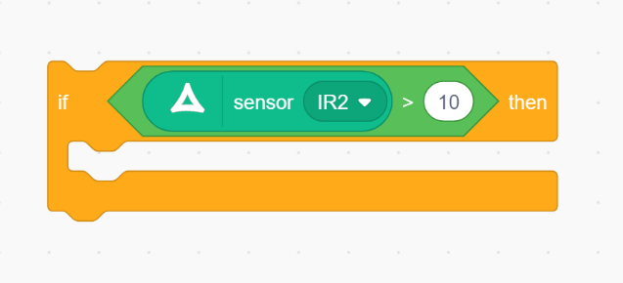
Drive at a certain speed | 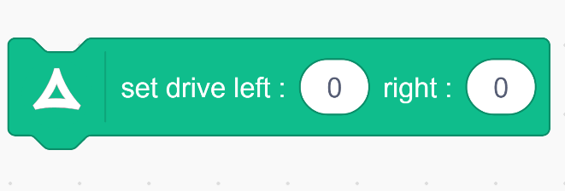
Cut each statement and the block for the activity.

