Note

The code for this lesson is fairly simple. If you choose, you can have students modify their code from the first lesson rather than creating a new program.
Modify the code in Lesson 1 by changing the speed as specified in the lesson. | 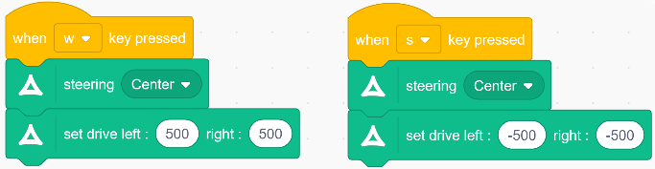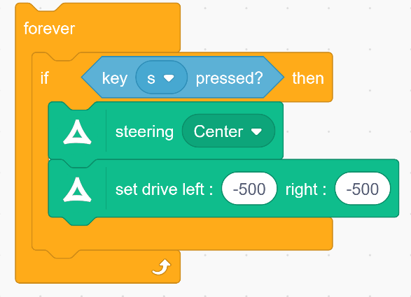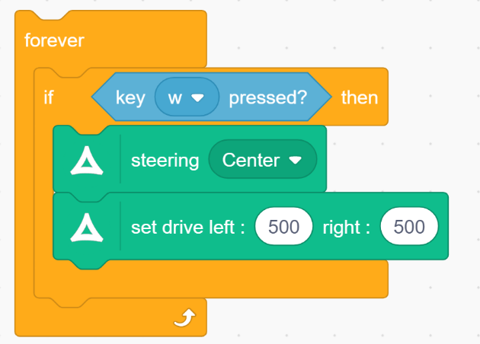
Add some code to make the car stop.  To stop moving, use a Go block and set the speed to 0. | 