Note

If you’d like to review the process for making a variable, see the code instructions for lesson 2.
Step 1  Make a variable, it will serve as the barrier to determine what counts as “day” and what counts as “night”. | 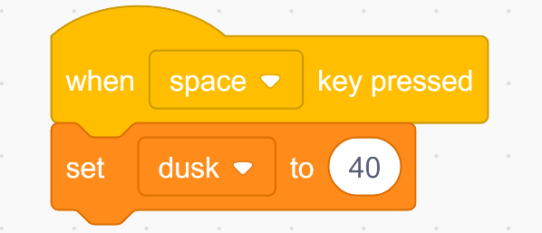
Step 2  The code for this lesson will have the same structure as the code in lesson 2.  Remember that a forever loop ensures that the code will continue to check over and over, rather than just once when you run the program.  You can choose to organize the program as two if statements, or as an if-else statement.  It will work the same either way. | 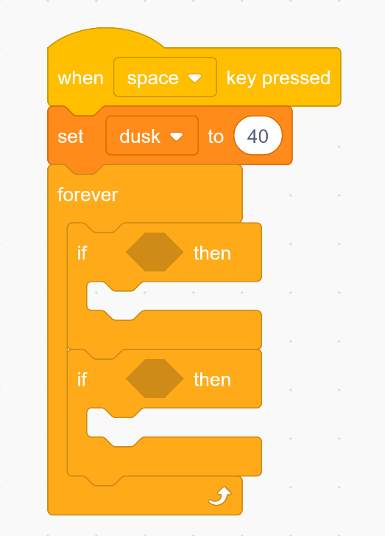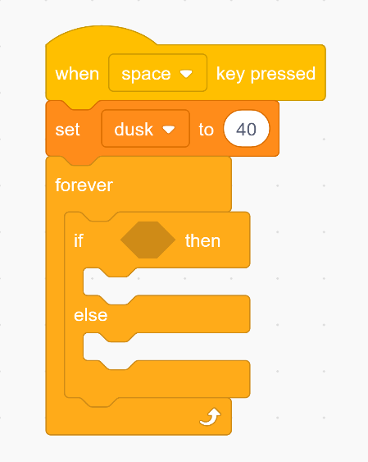
Step 3  Come up with a condition to check for based on the goal we set out in the lesson:  - When the car detects a light that is it is brighter than dusk, turn the headlights off  - When the car detects a light that is it is dimmer than dusk, turn the headlights on | 