Note

If you’d like to review the process for making a variable, see the code instructions for lesson 2.
Step 1  Make two variables,  - One will serve as the barrier to determine what counts as “ok” and what counts as “too hot”.  The other looks different than the variables we’ve worked with before  - Make a variable to record the temperature recorded by the car. Set it to the Temperature sensor value. | 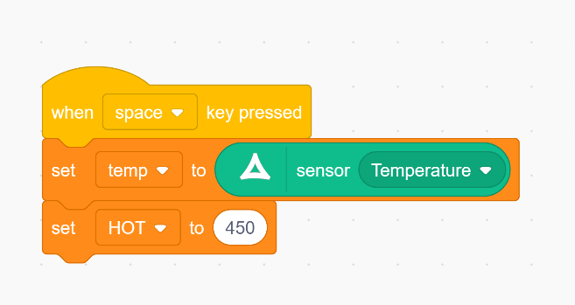
Step 2  This lesson’s code will follow the standard structure (students will probably start noticing a pattern) | 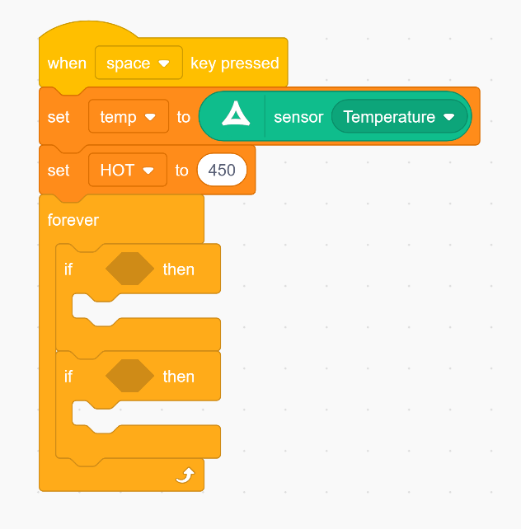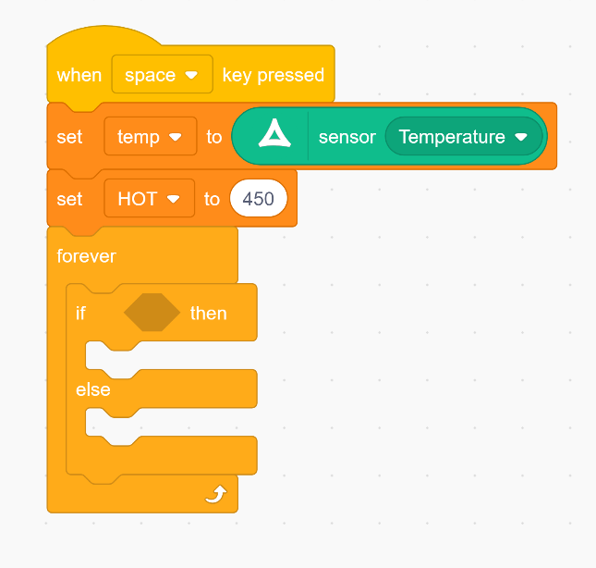
Step 3  Come up with a condition to check for based on the goal we set out in the lesson:  - When the car detects that the temperature of the car is acceptable, show (:  - When the car detects that the temperature of the car is unacceptable, show ): | 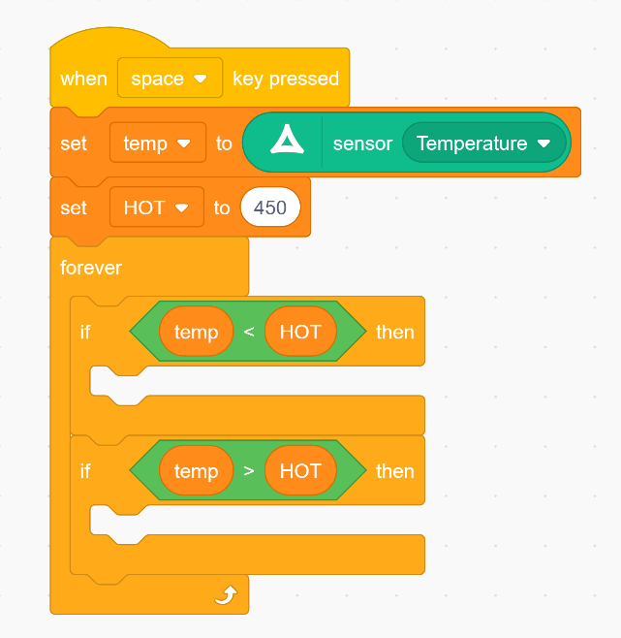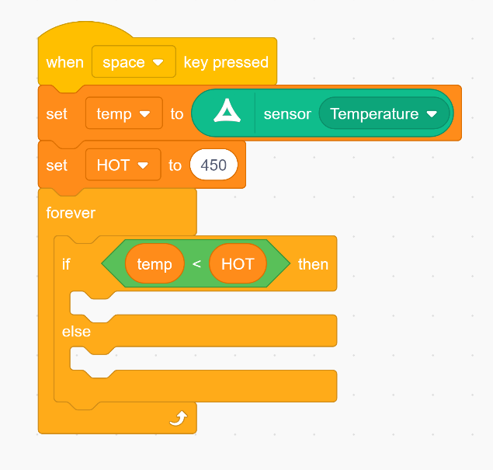
Step 4  To display something on the car’s LED screen, use the DIsplay block. You will need one for each Line (or column) of the screen.  The example provided displays a smile when the temperature is acceptable, and a frown when the temperature is too hot. | 