Note

In this lesson students learn how to combine the code from two previous programs into a new program with new functionality. This is an important skill to have as a programmer.
Step 1  Look at these code snippets from Lesson 2 and Lesson 5. They each have some component that we want.  When an obstacle gets too close we need to:  - Stop the car  - Turn off the lights  - Let the obstacle move away  Once the obstacle moves we need to:  - Turn the lights back on  - Start the car again | 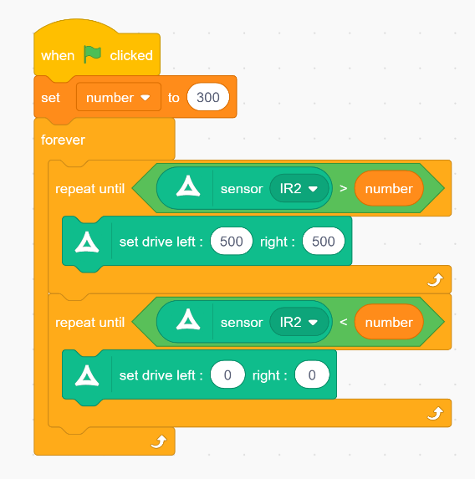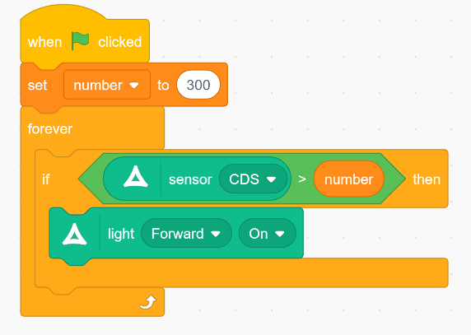
Step 2  The solution is pretty simple, you need to add the internal logic from the Lesson 5 but not the conditional. | 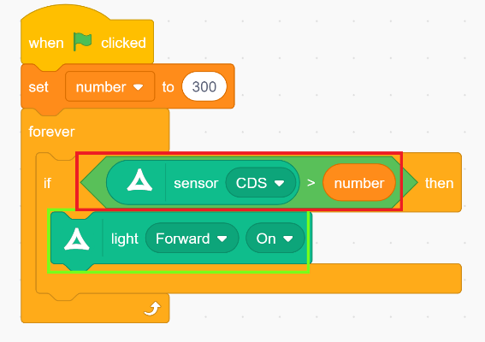
Step 3  Now when the obstacle appears the car stops and the lights turn off, and when the obstacle moved away the lights come back on and the car proceeds! | 