Note

In this lesson students will need to code using some Trial and error.
Step 1  Start by creating two variables,  - One will be IR data, that will act as the threshold for whether the car should park or not.  - The other will be the speed of the car (when it is not at a stop).  Use the power variable instead of typing 300 every time to cut down on typing, and to more quickly change the speed setting if needed.  IF the sensor value (of the left-side IR sensor) is greater than 30:  The car is near a wall and should initiate the parking protocol.  ELSE  Drive forward | 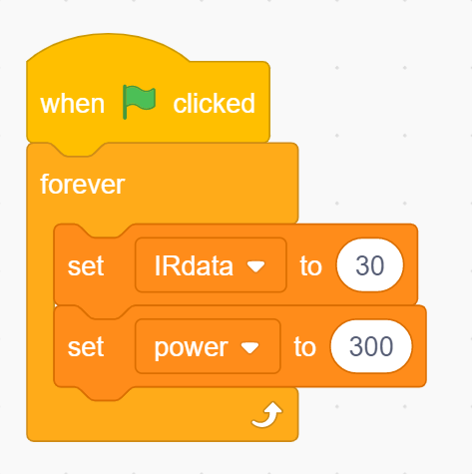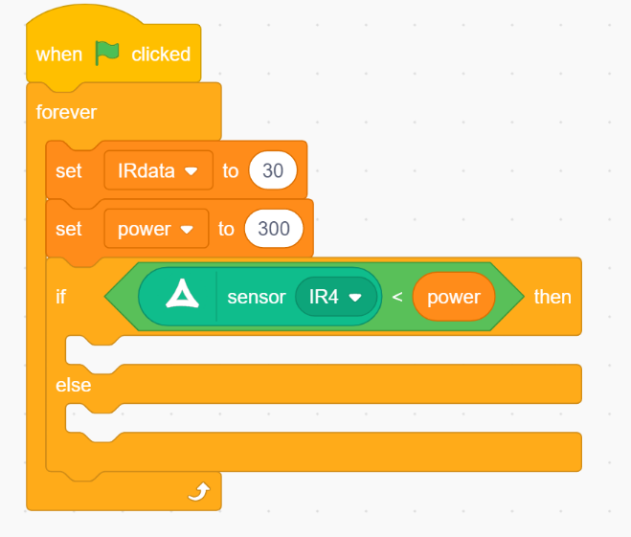
Step 2  To park: turn the wheels right while in a stopping position. Drive for one second to make a sharp turn, then stop. | 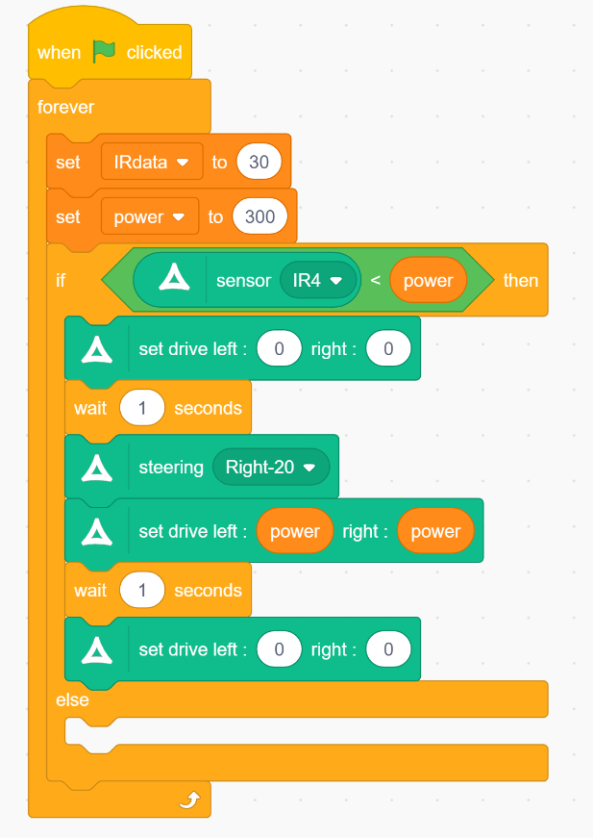
Step 3  If you DON’T want to park, return the wheels to the front position and drive.  Here is a full answer. This code may not work exactly as it was written in your classroom because the “parking spot” you make may look different. | 